Part 3
#1. Looking at the two original time series data set, the first thing that jumped out was the NaN value it had in ts1. I immediately thought that this dataset was incomplete. Furthermore, after deeper investigating, there doesn’t seem to be a pattern to the NaNs such as holidays or weekends. It was random dates, so I assume that it was just days when this company was closed or days that they forgot to fill this information in. I also found that there was a total of 40 NaNs for ts1. I did the same thing for ts2 and it had a total of 30 NaNs. As for seasonality, there seems to be some as shown by repeated movement from the time series graph. There is seasonality throughout each week as it seems that certain days are busier than others. A 7-day moving average could potentially unveil this trend. From the time series graph, I do notice a few outliers in ts1 and one in ts2.
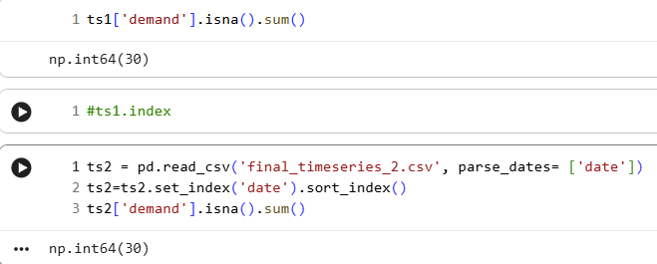
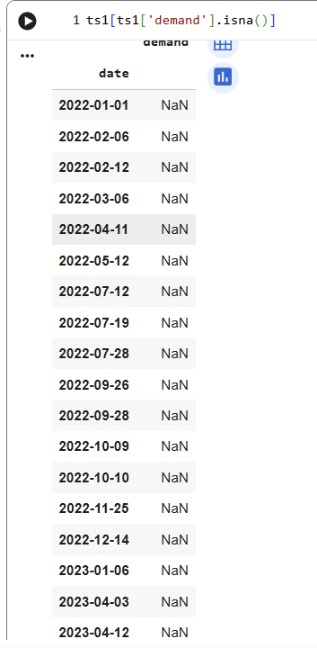

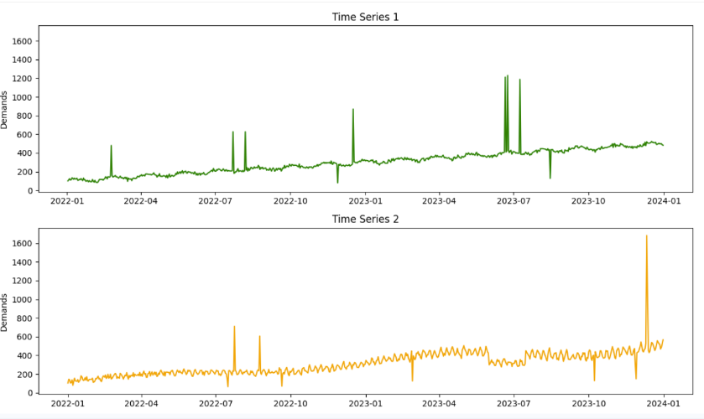

#2. Before using AutoML, I had to make sure that all dates were accounted for, fix the missing values and correct the outliers if any. To fix the dates, I found first and last date of the time series and created a panda date range that went from that first day until the last date. Then, I reindex both time series to the updated date range. To fix the missing values, I asked the AI agent within Github for help. It added the .interpolate() method to fill in the missing values. However, this only filled in the missing values in the middle of the dataset. It later added the .bfill() and .ffill() method to backfill and forward fill any missing values. Lastly, to test if there were indeed outliers, the AI agent used the Inner Quartile Range method. Once it found the lower and upper bounds, it tested to see if any value fell outside of those two ranges. From the results, there were four outliers from ts1 and three from ts2. To fix these outliers, I decided not to remove them but to smooth them instead. By asking the agent, it used the .clip() method to set anything lower than the lower IQR bound = to the lower IQR bound and similarly the same thing to the upper IQR bound. The reason why I decided to keep these outliers is because I didn’t want to through away any data. So, by replacing them with the highest or lowest reasonable value instead, they can still be included.
#3.
Exponential Smoothing: This is a model that places more importances to closer values and less importance on older ones. As a result, recent data are more relevant. This type of model is useful on data that doesn’t have any trends and doesn’t do well with forecasting out far.
ARIMA: This is a model that uses previous data to forecast out new predictions. It also uses the residuals of previous forecast to improve on its predictions. However, it doesn’t do well with seasonality.
Prophet: This is a forecasting model that is designed for businesses. It excels with trends such as daily, weekly, or yearly trends.
#4.
TS1_90days = Prophet
TS1_180days = Prophet
TS2_90day = ARIMA
TS2_180days = ARIMA
Looking back at the definitions of each model, it doesn’t surprise me that the Prophet model was the best in Times Series 1. However, I was surprised that it also wasn’t the best model in Times Series 2. After revisiting the clean dataset, I believe that the dip in Times Series 2 from roughly June 2023 – July 2023 through off the seasonality of that dataset which cause the Prophet model to not score as high as the ARIMA model.
#5. (Skipped)
#6. Overall, I really enjoyed Part 1, 2, and 3 of this project. I enjoyed it because it reflected real-world data scenarios, such as missing dates and values. I also enjoyed GitHub AI agent because it did exactly what I wanted it to accomplish. The code it generated was straightforward, which made it easy for me to follow and understand. It also introduced me to new methods that we haven’t learned yet, but I was still able to understand how they worked. Lastly, I hated the Azure ML part. I spent almost two days trying to figure out where things are. When looking at youtube videos or online tutorials, they were based on older user interface which frustrated me a lot. Also, I felt it didn’t help when we haven’t gotten a lot of experience with Azure. I think we briefly touched on it in 1-2 classes last Spring. This project was very stressful for me because not only was I not familiar with this application, but it was for a final project worth a lot of points. Overall, I felt that if we were to use an application that was much more user friendly, I would have enjoyed this project even more.

